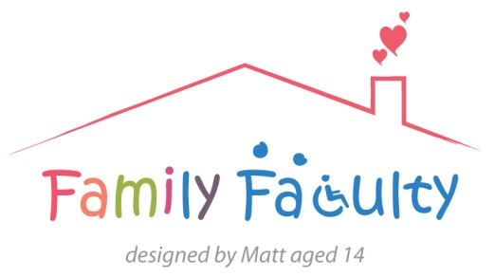
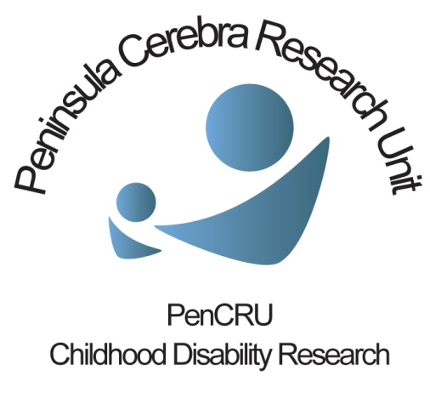

Education Collaboration Project meeting
Tuesday 28th January 2014 10am-1pm
Present: Mary Fredlund, Julia Melluish, Kirstin Payne, Jane Ring, Lisa Soanes, Tricia Stone, Hazel Lawson, Brahm Norwich, Jane Seale, Sharon Blake, Meghan McCrory, Chris Morris
Apologies: Antonia East, Ursula Easton-Pool, Lee Jones, Diane Kay, Lynn Pashby, Josephine Roberts

Introduction
Parents have often discussed issues around school and education at PenCRU meetings. As health researchers we don’t have specialist knowledge around such topics, and sought to collaborate with colleagues who specialise in Special Educational Needs and Disability at the University of Exeter.
Those present introduced themselves, and CM outlined the purpose of the meeting:
· Think about how families and education/health researchers can work together
· Discuss potential ideas for research projects and areas of shared interest
· Consider what topics might be appropriate to pursue

This was also a chance for members of our Family Faculty to find out about the type of research that the Education Department conduct. Parents described their own varying good and bad experiences when engaging with schools.

Main discussion
There was a general positive sentiment about collaboration from all sides.
Many options were discussed for future avenues that such collaboration could take. A common theme that was touched upon repeatedly throughout the discussion was around the transfer of knowledge. This may be from research to policy makers, but also between families and schools, within schools themselves, and between health and education. It was agreed that there is not a lack of research around health and education, but that interaction between the two could be improved. Focus was also felt to be needed on how to ensure that such information is actively used when working with disabled children and young people, or children with additional needs.
A project idea was identified whereby a model based on reversing a traditional parent/teacher meeting could take place for parents to become more connected with the schools practices and transfer their knowledge of their child in a valued way. Possibilities of bringing in multidisciplinary members (such as OT’s) into this process were also discussed. Systems of structured interviews have been developed previously, and are now a commercial enterprise.
It was also discussed that such a project would be highly relevant in the current context of policy developments around integration of health, education and social care.
It was noted that developing partnership with schools and teachers in primary/secondary and mainstream/special educational settings was crucial for any projects. Consideration was given towards engaging schools to work with (mainstream, special, primary, secondary, early education, post 16, or schools that we have worked with before). It was felt that the emphasis at this stage should be on primary and secondary schools. Relationships already exist with many schools so we should seek to engage representatives on this collaboration.
We also discussed characteristics of schools that promote inclusion more generally. BN suggested that the Institute of Education and others have carried out research on this topic previously http://eppi.ioe.ac.uk/cms/LinkClick.aspx?fileticket=xRK8efFm_jk%3D&tabid=749&mid=1738 and http://eppi.ioe.ac.uk/cms/LinkClick.aspx?fileticket=juIcqkP5Q8U%3D&tabid=276&mid=1096
http://www.csie.org.uk/resources/inclusion-index-explained.shtml
Other discussion touched upon influencing training of teachers and those working in education, both pre and post qualification, and the increasing potential role for technology to support processes.
Conclusion
The meeting was very positive and highlighted that there is a lot to be gained and interest in such collaboration. Name of the future project was suggested as ‘Empowered Parent, empowered Teacher Project’ or to contain the word ‘Partnership’.
Next steps
CM and BN (and others) will explore potential funding streams e.g. Educational Endowment Fund and Waterloo Foundation (below) and other opportunities charities etc, all to circulate any other relevant links around the group
http://educationendowmentfoundation.org.uk
http://www.waterloofoundation.org.uk/ChildDevelopmentAboutTheProgramme.html
BN will look into evaluative evidence of previous initiative and circulate information
Further consideration to be given towards contacts to engage primary and secondary schools, mainstream, special and/or schools we have worked with before, and also who to work with in schools (i.e. TA’s, teachers, management, governors, OT’s, Speech and Language Therapists).

