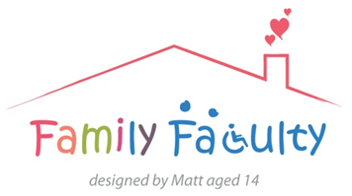
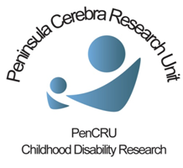

Wii-CP0 Meeting
Thursday 13 November 2014
Veysey, Room 006

Present: 5 x Family Faculty -Tricia, Julia, Kirsty, Sarah, Vikki
4 x PenCRU – Sarah, Chris, Katharine, Anna
1 x Professional - Steve
Remote input: 3 x Family Faculty - Karen
Apologies: 1 x Family Faculty - Mike

Welcome and introductions

Introduction to Wii-CP0
- Sarah introduced the Wii-CP0 study and explained how the trial is going to run.
- It is a feasibility study that will enrol approx. 30 children from Sussex – the wider research team is based here.
- There are two phases: a questionnaire to ask parents of children with cerebral palsy about their current active console game use, and a randomised controlled trial exploring the benefits of directed home use of a Wii Fit on movement abilities in children with cerebral palsy.
- The PenCRU team will work in an advisory capacity for the trial.
Review of trial documents
A number of study documents are required for the trial. Documents were reviewed and discussed within the group. Feedback on these documents was collated and circulated to the wider research team.
Next steps
Once the documents have been modified and the study protocol has been finalised, ethical approval will be sought for the project. We will be in touch to let meeting attendees know about the impact their feedback has had on the documents and how the trial is progressing.

