
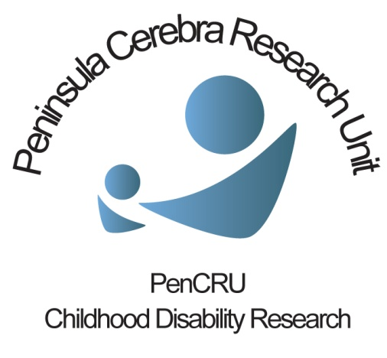
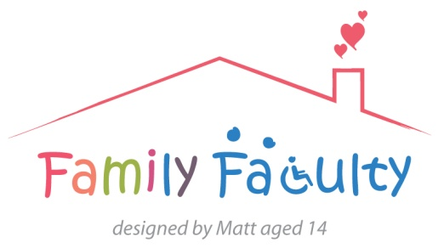

Healthy Parent Carer Project meeting
18/06/2014 Veysey Building
Family Faculty and other colleagues: Aleksandra, Bel, Jacinta, Julia, Kirstin, Lynn, Mary, Mirtha, Penny, Peter, Sheri, Tricia PenCRU: Chris, Katharine, Val
Overview
In this meeting we:
Gave an update of the work done so far
Discussed different ways the project could be funded and taken forward
Discussed different aspects of the research design
What next?
Chris will prepare the application for funding from the Medical Research Council. The deadline is in September. He will ask members of the group to read the application before submission
There will be an update meeting later in the autumn
Work so far:
Val gave an overview of previous meetings and how we had reached the current ideas for research. To save space here we won’t recap – please see the website for previous meeting notes (www.pencru.org/projectsmeetings/meetingnotes)
Taking the project forward and funding:
Chris told the group that we still intend to apply for funding from the Medical Research Council (MRC) to develop this research and that the deadline is on the 12th September. Chris will ask members of the group to review and comment on the application before it is submitted. PenCRU will continue working on this project theme even if the MRC application is unsuccessful.
Discussion points:
We discussed a range of topics which will help Chris prepare the funding application. These included:
- Jacinta told us that the health trainer one-to-one support offered in Devon is based on the same behaviour change techniques we have thought about. The Community Development Team work with groups that for one reason or another are at increased risk of poor health to look at what they want to change and how to go about it. Although these programmes may be slightly different to what we are trying to achieve in this research project there are clear opportunities to work together and learn from these programmes.
- We discussed whether visiting an accredited health trainer on a one to one basis or working with other parents as a group would be more credible. The group felt that both were important and could be used in parallel depending on the specific objective for the parent. By coming together as a group it was felt that people could be stronger to pursue individual goals; part of the programme could be to raise awareness of what other specific services are available to them.
- The importance of the community involvement and sense of identity amongst parent carers was discussed particularly with reference to giving permission to take time for yourself and encouragement to make changes to behaviour. How to create that environment remains a challenge when so many parent carers are isolated.
- Should the programme be specifically for mothers or for both parents? Arguments were put forward for both cases but we recognised that we have to start somewhere and that perhaps we should focus on mothers in the first instance as there was a greater perceived need and number of mothers who are primary caregiver. We did not rule out fathers in the future.
- We contrasted the importance of flexibility of the programme with goals and timelines set by the individual so that people don’t feel pressured and therefore more likely to fail, versus the need that some people may have to feel “checked up on” in order to succeed.
- The sustainability of the programme: could it be used by groups all over the country who just download the manual and run themselves? This is challenging from a research perspective to ensure what was actually being ‘delivered’ in each group.
- We would not be measuring effectiveness in this early project however asking people a few questions about their wellbeing and self-efficacy could be useful for us to gauge how people feel the intervention is working and to the individual to think about their journey, where they started from and where they got to by the end of the programme.
- Measuring effectiveness would be an essential part of evaluating the programme in the long term and one suggestion was to look at the role of cortisol and other biomarker outcomes as objective measures of stress reduction.
- It was noted that sometimes interventions run for a number of weeks and then just end leaving people with a sense of ‘what now?’ We discussed the disadvantages of fixed length programmes versus ongoing regular drop in sessions (such as in the Alcoholics Anonymous model) which may help people achieve and sustain their goals.
- An aim of the early stage research would be to develop a ‘curriculum’ of what might be included in the programme. The programme itself might last for 6 weeks or so but might form the basis for an ongoing support group who may arrange their own meetings, access learning and development materials and invite speakers. The success of such an ongoing group would be dependent on someone having the drive to lead it.
- Finally, we discussed whether using existing settings to establish groups for this phase of the project would be a good idea e.g. special schools (but advertising through outreach workers to mainstream schools as well), or existing community groups. This may provide us with an initial way-in to try out the different curriculum activities before setting up brand new groups.

